*ALMP fleet managemenT and Telematics*

Business Case

|  |  |
| --- | --- |
| Business Case | |
| Project Title | *ALMP Fleet management and Telematics* |
| Project Sponsor | Ramandeep Singh Virdi |
| Project Manager: | Arman Singh |
| Technical Manager: | Vinod Kumar Tiwari |
| Project Owner: | Dheeraj Pant |

**Document Control**

|  |  |  |  |  |  |
| --- | --- | --- | --- | --- | --- |
| Version No. | Date | Author | Change History | Reviewed By | Approved By |
|  |  |  |  |  |  |
| V 0.0.1 | 12-10-2023 | Vinod Kumar Tiwari |  |  |  |

Contents

ExECUTIVE SUMMARY 4

PROJECT DESCRIPTION 4

Delivery Cost and Budget 5

Savings and fleet compliance 6

• Improved safety and compliance 8

• Reduced fuel costs 8

• Lower overall operational costs 8

• Increased productivity 8

• Better communication 8

Assumptions 8

# ExECUTIVE SUMMARY

Telemetry IoT integration with ALMP provides end-to-end control and transparency for fuel consumption, fleet optimization, maintenance costs and safety.

This innovative fleet management solution optimizes driver and vehicle utilization through real-time data tracking, achieving increased productivity and cost reduction.

Key business goals as below:

* Behavior Assessment
* Crash Alerts
* Training Requirement for Safe Driving
* On-trip & off-trip Monitoring
* Assets Utilization
* Expense & fuel management
* Efficiency monitoring
* Complaint management
* Green points riders ranking

Following is the projection for next five years for the spending, savings, and net cost savings:

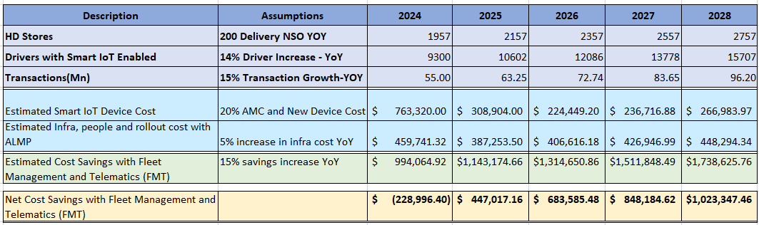

# PROJECT DESCRIPTION

ALMP with an integration approach and fleet management will be helping in reduction of the run cost for drivers and vehicles with Americana Last Mile Platform product to achieve more efficient utilization of riders and vehicles to optimize journey and order delivery experience.

* Automated Driving Habit Assessment
  + Performance Report
  + Driver Training
  + Prevent unsafe driving.
  + Driver Management
* Crash Alert
  + Over Speed Alarm
  + Accident Alerts
  + SMS Alerts
* Optimize Fleet Delivery Routes with On-trip & off-trip Monitoring.
  + Fleet live tracking
  + Geo fencing
  + Route allocation

# Delivery Cost and Budget

ALMP platform integrated fleet management solution will initially require having smart devices (IoT) enablement on vehicles available with the drivers. Where with different markets we can consider the device costing with breakup marketwise will be as per below table:

|  |  |  |  |
| --- | --- | --- | --- |
| **IoT Device Cost Market Wise** | | | |
| **Market** | **Total Drivers** | **Unit Price** | **Expected Cost ($ per year)** |
| **($ per year)** |
| Bahrain | 275 | $ 120.00 | $ 33,000.00 |
| UAE | 2,695 | $ 120.00 | $ 323,400.00 |
| Kuwait * | 1,192 | $ 120.00 | $ 143,040.00 |
| Egypt * | 1,601 | $ 120.00 | $ 192,120.00 |
| Oman | 21 | $ 120.00 | $ 2,520.00 |
| Qatar | 420 | $ 120.00 | $ 50,400.00 |
| KSA | 157 | $ 120.00 | $ 18,840.00 |
|  |  |  |  |
| **Estimated Total Device Cost (per year)** | | | **$763,320** |

Notes:

1. Pilot markets in FY-24 can be start with Kuwait and Egypt.
2. GPS tracking (IoT) device connectivity cost will be additional (if any) based on market and providers.

**Other Costs**

|  |  |  |  |
| --- | --- | --- | --- |
| **Cloud Infra and Licenses Cost** | | | |
| **Environments** | **Items** | **Unit Price** | **Expected Cost ($ per year)** |
| **($ per month)** |
| DEV | ALMP DEV ENV (CAPEX) | $ 1,171.54 | $ 14,058.53 |
| QA | ALMP QA ENV(CAPEX) | $ 1,171.54 | $ 14,058.53 |
| UAT | ALMP UAT ENV(CAPEX) | $ 2,343.09 | $ 28,117.06 |
| PROD | ALMP PROD ENV (OPEX) | $ 11,715.44 | $ 140,585.28 |
| DR | ALMP DR ENV (OPEX) | $ 1,171.54 | $ 14,058.53 |
| Licenses & APIs | Google Maps, Monitoring, Atlassian, Confluent, API etc. (CAPEX+OPEX) | $ 6,000.00 | $ 72,000.00 |
|  |  |  |  |
| **Estimated Total ALMP Infra Cost** | | | **$282,878** |

With all the spending below will be the cost of delivery of Fleet Management System with ALMP integration scope:

|  |  |
| --- | --- |
| **Estimated Total Cost of Fleet Management System** | |
| Estimated Total Device Cost (per year) | $ 763,320.00 |
|  |  |
| Estimated Total ALMP Infra Cost (per year) | $ 282,877.92 |
| Estimated Total Rollout Cost | $ 35,000.00 |
| Estimated Total Development Team Cost | $ 141,863.40 |
|  |  |
| **Total Estimated Cost of Delivery** | **$ 459,741.32** |

Note: Market-wise DoD will increase, and the cost of devices will be gradually reduced as this feature will be enabled with the DoD partners.

# Savings and fleet compliance

A FOC trial was conducted in Bahrain with one of the partners with below summary:

|  |  |  |  |  |  |  |  |  |  |  |  |  |  |  |
| --- | --- | --- | --- | --- | --- | --- | --- | --- | --- | --- | --- | --- | --- | --- |
| **Country** | | **Stores** | | | **GPS Trackers Installed** | | | | | **Trial Duration** | | | **Trial Month** | |
| BAH | | 1 | | | 3 | | | | | 30 Days | | | 23-Aug | |
| Bike # | Driver Name | | Fuel Consumption July (L) | Fuel Consumption Aug (L) | | Orders Delivered July | Orders Delivered Aug | July L/Order | Aug L/Order | | Aug Mileage | L/KM | Var L/Order | Saving/Order (0.140) |
| 29562 | Momin | | 103.595 | 83.043 | | 590 | 529 | 0.176 | 0.157 | | 3010 | 0.0276 | -0.0186 | -0.0026 |
| 29574 | Uzaal | | 105.18 | 111.03 | | 548 | 570 | 0.192 | 0.195 | | 2806 | 0.0396 | 0.0029 | 0.0004 |
| 29590 | Anil | | 157.833 | 127.303 | | 454 | 524 | 0.348 | 0.243 | | 3306 | 0.0385 | -0.1047 | -0.0147 |
| Total | | | 366.608 | 321.376 | | 1592 | 1623 | 0.230 | 0.198 | | 9122 | 0.0352 | -0.0323 | -0.0045 |

|  |  |  |  |  |  |  |
| --- | --- | --- | --- | --- | --- | --- |
| Savings per order | #Orders per month | Savings per day | Savings per month | Annual Savings (in BD) | Exchange Rate BD-USD | Annual Savings in $ |
| 0.02 | 4000 | 80 | 2400 | 28800 | $2.65 | **$76,320** |

Out of the above case study and trial here with the current business case we are taking the savings per order 0.0094 BHD ($0.025) with approx. $35870 yearly savings assumptions instead of 0.02 BHD as per trial case study.

|  |  |  |  |
| --- | --- | --- | --- |
| **Estimated Cost Savings Market Wise** | | | |
| **Countries** | **Savings Per Order ($)** | **Orders Per Month** | **Annual Savings in $** |
|  |
| Bahrain | 0.025 | 125,629 | $ 37,688.61 |  |
| UAE | 0.025 | 1,466,923 | $ 440,076.87 |  |
| Kuwait | 0.025 | 572,713 | $ 171,813.90 |  |
| Qatar | 0.025 | 290,265 | $ 87,079.40 |  |
| KSA | 0.025 | 313,497 | $ 94,048.95 |  |
| Egypt | 0.025 | 495,239 | $ 148,571.68 |  |
| Oman | 0.025 | 49,285 | $ 14,785.52 |  |
|  |  |  |  |  |
| **Estimated Total Cost Savings** | | | **$994,065** |  |

Additional savings

In addition to above savings further the smart devices with GPS trackers will also help reduce Stolen Bikes with following:

|  |  |  |  |
| --- | --- | --- | --- |
| **Estimated Cost Savings on Vehicles Theft** | | | |
| **S. No.** | **Year of Theft** | **Total Theft** | **Estimated Vehicle Cost** |
|  |
| 1 | FY-21 | 7 | $ 91,000.00 |  |
| 2 | FY-22 | 4 | $ 52,000.00 |  |
| 3 | FY-23 | 3 | $ 39,000.00 |  |
| 4 | FY-24 | 5 | $ 60,666.67 |  |
|  |  |  |  |  |
| **Total Estimated Cost of Theft Vehicles** | | | **$ 242,666.67** |  |

Beyond cost benefits

# Improved safety and compliance

# Reduced fuel costs

# Lower overall operational costs

# Increased productivity

# Better communication

# Assumptions

Below is the list of assumptions made during this draft version of documentation with basic costing, budgeting, and savings can be listed in below:

|  |  |
| --- | --- |
| **Assumption** | **Actions to validate Assumptions** |
| Microsoft Azure Cloud BoQ for Production is considered as **$11,715.44** | Validation can be done with Etisalat. |
| Monthly order volume considered from ALMP LAMDA DB with 18% order volume for 1click in October 2023 | Can be validated with the monthly order volume available in LAMDA DB for Power BI reporting tables. |
| ALMP Dev, QA is considered 10%, UAT 20% and DR 10% of Production BoQ. | Below attached projected ALMP production BoQ component list shared via Etisalat. |
| For savings only considering 53% values to consider in estimates. | Trial case study with a few IoT devices are available above to validate. |

**ALMP Cloud (BoQ) Considered for infrastructure calculation:**

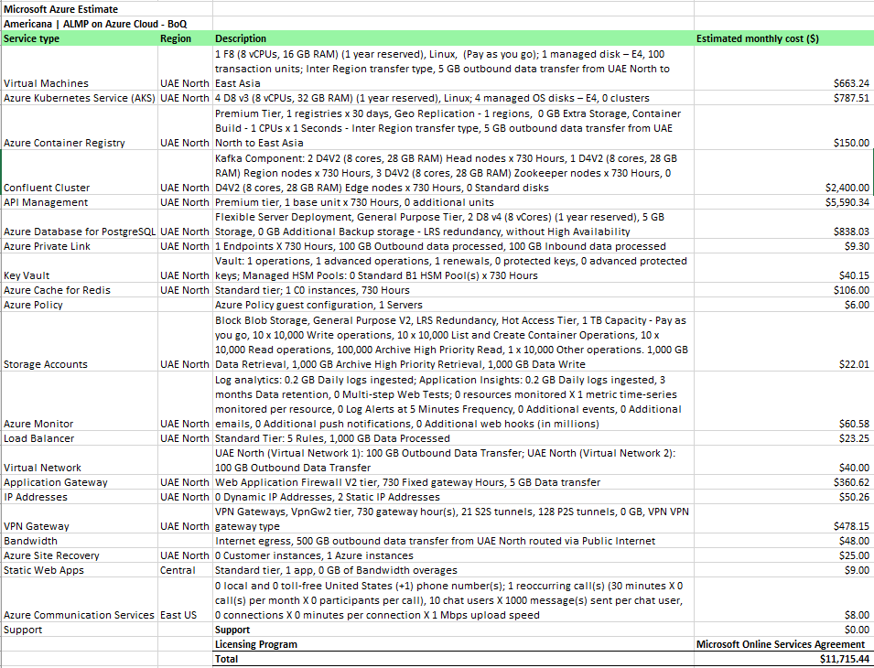

Appendix A: Business Case - Approval

The undersigned acknowledge they have reviewed the ALMP Fleet Management **Business Case** and agree with the approach it presents. Changes to this **Business Case** will be coordinated with and approved by the undersigned or their designated representatives.

|  |  |  |  |
| --- | --- | --- | --- |
| Signature: |  | Date: |  |
| Print Name: |  |  |  |
| Title: |  |  |  |
| Role: |  |  |  |

|  |  |  |  |
| --- | --- | --- | --- |
| Signature: |  | Date: |  |
| Print Name: |  |  |  |
| Title: |  |  |  |
| Role: |  |  |  |

|  |  |  |  |
| --- | --- | --- | --- |
| Signature: |  | Date: |  |
| Print Name: |  |  |  |
| Title: |  |  |  |
| Role: |  |  |  |